ICES CM 2017/F:509
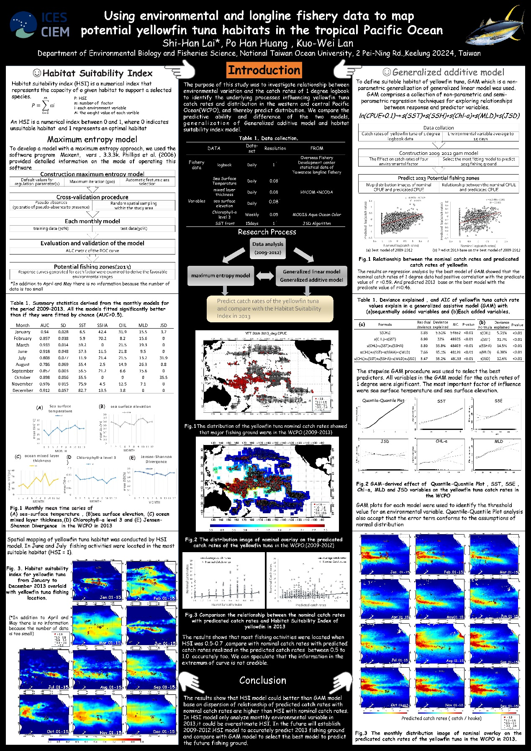

Using environmental and longline fishery data to map potential yellowfin tuna habitats in the tropical Pacific Ocean

Author: Shi-Han Lai*, Kuo -Wei Lan , Po Han Huang

Abstract:
The purpose of this study was to investigate relationship between environmental variation (SST, SSHA , Chl-a , MLD and JSD front ) and the catch rates of 1 degree logbook and observer data to identify the underlying processes influencing yellowfin tuna catch rates and distribution in the Pacific Ocean, thereby predict the potential fishing ground. All variables in the GAM model for the catch rates of 1 degree logbook and observer data were significant (p<0.01) in the period from 2009~2013. The cumulative deviance explained by the GAM models were 34.3% and 26.2%, respectively. The result showed the sea surface temperature is the most important factor in the model. The catch rates had positive effect on the higher SST, SSHA about -20~25 cm , Chl-a about < 0.2 mg/m³ , MLD about 20~60m and JSD about 0.4~0.6. The predicted catch rates of 2013 based on the model of 2009~2012 also showed the high correlation of r=0.57 for logbook and r=0.46 for observer data, respectively. In conclusion, the results suggested that models of catch rates of 1 degree data that incorporate relevant environmental variables can be used to infer possible responses in the distribution of highly migratory species and the observer data can use to detect the subtle change of the target fishing grounds.

Keyword: Pacific Ocean, yellowfin, GAM, Spatial distribution

Contact Author: Shi-Han Lai / Department of Environmental Biology and Fisheries Science, National Taiwan Ocean University, 2 Pei-Ning Rd, Keelung 20224, Taiwan
Email: sh1995lai@gmail.com

