WGBIOP Guidelines for Workshops on Maturity Staging Calibration

Last update:
WGBIOP 2020
Webex online

Version history
Version | Author | Date | Changes
Version 3 | ICES PGCCDBS | March 2010 | Changes based on WKMSSPDF. Topics to consider when preparing a Workshop  f) modified and i) added.  Topics to consider during the Workshop  e) added.  b)ii) modified  Guidelines for collecting maturity data and histological analyses for maturity workshops  8) modified
Version 4 | ICES PGCCDBS | February 2012 | Changes based on WKMSSPDF2012: recommendation to create European Fish Maturity Stagers Forum added
Version 5 | ICES PGCCDBS | February 2014 | Changes based on WKMATCH recommendations
Version 6 | ICES WGBIOP | September 2015 | Text improvement  3 k) Added after discussion
Version 7 | ICES WGBIOP | October 2016 | Text improvement
Version 8 | ICES WGBIOP | October 2017 | Text improvement
Version 9 | ICES WGBIOP | October 2018 | Text improvement and changes based on WKASMSF recommendations
Version 10 | ICES WGBIOP | October 2019 | Text improvement and changes based mainly on SmartDots recommendations
Version 11 | ICES WGBIOP | October 2020 | Text improvement. Add link to the Smartdots Maturity manual in the text. Addition of gonad’s images

Introduction
The main objectives of a maturity staging workshop are: i) to agree on a common maturity scale for the species/stock (see WKASMSF 2018 report), based on a comparison of existing scales and standardization of maturity determination criteria; ii) to establish correspondence between old and new scales so that time series of previous data can be converted; iii) to reduce sources of error in maturity determination by validating macroscopic staging, and iv) to propose an optimal sampling strategy to estimate accurate maturity ogives.
A Fish Maturity Stagers Forum (MSF), similar to the Age Readers Forum, has been created. In 2018 the SmartDots tool (https://www.ices.dk/marine-data/tools/Pages/smartdots.aspx) was further developed to carry out maturity staging exercises and workshops. A test run/exchange on DAB took place in 2019, and it is recommended that the SmartDots platform is used for future exchanges and workshops. A SmartDots maturity manual has been created in order to simplify the use of the Platform during each maturity event http://ices.dk/publications/library/Pages/default.aspx?#k=Title%3Asmartdots%2C%20owstaxIdPublicationType%3AUser%20handbooks
WKMATCH (ICES, 2012) recommends the establishment of regular courses on maturity staging targeting observers normally collecting biological data and the laboratory responsible of this data collection.

Topics to consider when preparing a Workshop

- Identify sources of data that, at present, are used to collect maturity data and their current sampling protocols taking into consideration that macroscopic maturity staging can only be reliable if carried out 3 months prior to and during spawning, as reported by WKMATHIS (ICES 2017).
- To update the maturity information take into consideration the maturity data reported in the table “Material_techniques_and_preparation_methods_by_species_and_areas_for_fish_maturity” which is available on the ICES Data Quality Assurance Repository.
- Identify the metadata that are needed to accompany samples collected for analyses and specify it in the sampling protocols (see guidelines below).
- Gather published/grey literature information on the reproductive biology and ecology of the species / stock of concern with emphasis on the timing of the different stages of the reproductive cycle, particularly spawning time, defining clearly its duration.
- Studies are required on spawning synchronicity among individuals within a stock, as low synchronicity will mean there is temporal overlap of different stages (developing, spawning, regressing and/or regenerating).
- The organization for the collection of the samples and the methods for histological analysis need to be decided amongst the experts but guidance can be found below (Guidelines for collecting maturity data) or on the ICES DATA Quality Assurance Repository/ PGCCDBS Guidelines for collecting maturity data and histological analyses for maturity workshops.
- Maintain contact with participating countries to ensure adequate sample coverage is obtained prior to the workshop’s analyses of samples. In this sense the following should be ensured:
- Laboratories participating in stock assessment or data collection of the stock of concern may participate even if they do not routinely collect maturity data.
- Workshop participants should include sampling coordinators as well as experts on histology, maturation process and the reproductive biology/ ecology of the species of concern (or at least a related species).
- Ideally, fresh and/or frozen samples should be provided during the workshops. In case where fresh fish are collected during sampling, fresh samples should be made available for the workshop. Thus the spawning period of the species needs to be taken into account when setting the timing of the meeting. However, if fresh samples are not available frozen samples can be used. In cases where frozen samples are collected during sampling (i.e. some commercial catches), frozen samples should be made available for the workshop. It should be clearly stated if fresh or frozen samples are used.
- Any available histological slides and macroscopic images should be uploaded to SmartDots (by the workshop responsible) to be used as a tool prior to and during the workshop. This is especially important because results from the calibration exchange will point out possible discrepancies between labs which should be addressed during the workshop http://ices.dk/publications/library/Pages/default.aspx?#k=Title%3Asmartdots%2C%20owstaxIdPublicationType%3AUser%20handbooks
- Provide detailed protocols on collecting images of the gonads sampled, including at least a precise description of the quality of images (set-up of camera and format) and image calibration. Additionally, in case of histological images, agree on the histological protocol and microscope set-up (see guidelines for histological process below or the ICES DATA Quality Assurance Repository/ PGCCDBS Guidelines for collecting maturity data and histological analyses for maturity workshops).
- Gather information on how the data are, or could be used, in the assessment process (See ToR d in ICES 2019). For this reason a tight collaboration with stock assessment experts is encouraged.
- Put in place arrangements for histological analyses of collected material taking into account that all participants may not have facilities or resources to meet this requirement. Arranging for centrally located analyses has proved effective in the past and has ensured that adequate samples are validated. Consider bi-lateral agreements to cover the cost of such work.
- Each laboratory should carry out investigations into potential discrepancies in maturity staging between scientists within the laboratory, highlighting also the misleading stages that may arise during a previous workshop training. Accuracy may be estimated by means of whole-mounts (see WKASMSF 2018 report). They should also consider, if available, microscopic staging. If possible provide statistical analysis of precision and accuracy within the laboratory. Potential causes for lack of precision and accuracy should also be analyzed.
- Prepare a full set of reference material covering both the spatial and temporal aspects of the species/stock of concern. These consist of pictures of all maturity stages together with their histology report.
- Illustrated and validated manuals have been developed, i.e. GFCM ATLAS (2019) (http://www.fao.org/gfcm/publications/studies-reviews/99/en/), http://ices.dk/publications/library/Pages/default.aspx?#k=Title%3Asmartdots%2C%20owstaxIdPublicationType%3AUser%20handbooks or in preparation (CRR manual) in order to enhance accuracy in maturity staging among laboratories.

Topics to consider during the Workshop

- Provide information on participating laboratory procedures, including sampling procedures, macroscopic maturity determination process, maturity scale definitions and if applicable gonad preservation and histological methods, and protocols used to determine microscopic maturity.
- Provide a statistical report of picture exchange comparing observed maturity stages with validated histological stages for the workshop participants to consider. Also other validation methods can be taken into consideration as whole mounts and GSI-HIS. Differences in staging between laboratories should be statistically analyzed in terms of precision and accuracy; sources of discrepancies should also be analyzed.
- Resolve interpretation differences between stagers and laboratories both at macroscopic and microscopic scales. Differences may arise from:
- Using different maturity scales
- Different interpretation of the same macroscopic stages (terminology and precise definition of stages are critical issues)
- Different sampling protocols, e.g. timing and/or gear selectivity or availability, see guidelines for collecting maturity data below.
- Different interpretation of gonad structures and gamete development in histological slides. This should not be an issue, so experts on gametogenesis should be involved in workshops.

- Agree on a single maturity scale. Consider the following aspects:
  - Follow the international agreed scales (see the WKASMSF (ICES 2018) report) for reporting to ICES and GFCM. The ICES mandatory maturity scale named as “WKMATCH 2012 maturity scale revised” in the WKASMSF report has been renamed as “SMSF (Sexual Maturity Scale for all Fish ” https://vocab.ices.dk/?CodeID=201781 to avoid it being confused with other previous scales used within ICES. The same acronym is present in the “Maturity Scales used at Institutes”file available on the ICES Data Quality Assurance Repository.
  - Describe the stages precisely avoiding ambiguity and overly subjective description (like colour descriptions), for example, give measurements instead of saying “bigger”.
    - If two stages are hard to distinguish macroscopically, they should both be indicated. This often occurs with regressing (Da) and/or regenerating stages (Db) that are confused with the stages immature (A) or developing, but functionally immature (Ba). In these cases, histology must be used to confirm the maturity stage following what is reported during the WKMATHIS (ICES, 2017) on the histological validation of the ‘SMSF scale’.
    - As a calibration exercise, each participant should classify the workshop sample collection using the agreed maturity scale (SMSF) and any discrepancies in interpretation should be identified and resolved.
- Based on the experiences it is recommended that the maximum number of fish to stage in one session is no more than 120. However, the total numbers to stage should also take into account the species and any sample size requirements for statistical comparisons. This applies to fresh samples as well as images. If only frozen gonads are available, it must be reported.
Participants should indicate the level of experience on the determination of the maturity staging (basic or advanced). This will help on the analysis of the results of the calibration exercise.
- The results from the calibration exercise should be recorded to provide data for statistical analysis.
- Improvements in agreement due to the workshop should be analysed. Ideally a new exchange with a different set of samples should be used, not the ones already staged during the workshop. Discrepancies of maturity staging between participants should be improved analysing the age of the samples as well. They should be statistically analysed in terms of precision and accuracy.
- Use standard terminology from WKASMSF (ICES, 2018) for macroscopic and microscopic features from WKMATHIS (ICES, 2017).
- When a new agreed maturity scale is proposed the impact on maturity historical series has to be evaluated and the conversion table to the internationally agreed scale (SMSF) must be provided.
- The participants are highly encouraged to keep in touch after the workshop (perhaps for one year) in order to share and solve contingent problems in applying the common scale faced in each laboratory. SmartDots is a convenient tool to use for this exercise.
- Produce an agreed reference collection of preserved gonads, histological slides and images of gonads to be available for the scientific community. Pictures of histological slides can be made and distributed with referenced images (macroscopic ones) of these slides, as already done by the GFCM ATLAS of maturity (http://www.fao.org/gfcm/publications/studies-reviews/99/en/)
- The minimum output from species-specific workshops should be an illustrated manual (see the CRR handbook in preparation).

Topics to consider after the Workshop (follow-up actions)

Dissemination of the results is in principle the responsibility of the exchange and/or workshop coordinator.

- The full report of the workshop should be made available on the internet, and placed (in pdf-format) on the ICES Data Quality Assurance Repository (http://ices.dk/community/Pages/PGCCDBS-doc-repository.aspx).
- An extended summary of all workshops and exchanges should be submitted to WGBIOP.
- The coordinator has to make participants aware that they are responsible to communicate results from the exchange/workshop to colleagues in their institutes.
- Provide recommendations to stock assessment working groups and benchmarks on relevant issues derived from maturity stage studies, such as timing of sampling, changes on maturity time series, spatial differences on maturity, differential sex maturation, etc.

Protocol for regular sampling for histology at sea

Sampling method:

A sub sample of 1 individual per 5 cm length group per sex is taken randomly from the catch and stored on ice immediately. As it is likely that not all length groups are represented in one haul, the preferred sampling strategy is to commence the sampling by random selection of fish, but then as the length-groups get filled out, specific sampling for length groups not yet covered should be performed.
The sampling should preferably be spread out on as many locations as possible; however, it is of higher priority to fill out as many length groups as possible.

Data collection (see table 2):

Each individual is given an individual identification number and for each individual the following information should be recorded:

- Sex
- Total length (cm)
- Total weight (g)
- The maturity stage
- Gonad weight (g)
- Gutted weight (g)

A series of photographs are to be taken during the process:
- Fish with gonad is photographed (see example 1 and 4, remember to include identification number)
- Fish with gonad lying next to it is photographed (see example 2)
- Close-up photo(-es) of gonad is taken (see example 3,5 and 6)
- Gonad cut with its inside well visible ( see example 7)

Preservation of tissue:
Minimum: take approx. 1x1 cm slice from middle part of one of the gonad lobes and preserve the tissue in histoformaldehyde (see below) in the ratio 1:10. Important: choose either right or left gonad lobe at start of sampling session and continue sampling from same lobe throughout the sampling period. Note the lobe taken from (right/left).
Preferably, for females, take two tissue samples from the chosen lobe; ovary tunica + tissue. For males: sperm duct + tissue (see image).

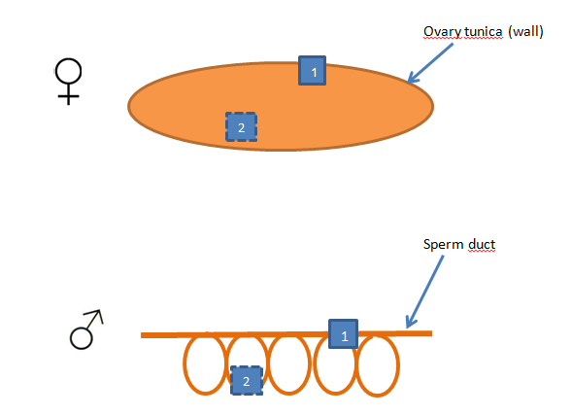

Sample ID
Note cruise name, station, date, latitude, longitude, the initials of the persons who collected the fish, and to which stock the fish belongs if possible.

Analysis of histological sections
In order to have a base of comparison among the histological section estimation of the different readers it is recommended to draw a table as follows (see cell types reported in WKMATHIS (ICES, 2017)

 | Type of cells - Oogenesis
 | OG | PG | CA | Vt1 | Vt2 | Vt3 | HYD | POFs | AT | Assigned maturity stage
Fish1 | x | x |  |  |  |  |  |  |  | A
Fish2 |  |  |  |  |  | x | x | x |  | C
Fish3 |  |  | x | x | x |  |  |  |  | Bb

References
ICES, 2012. Report of the Workshop for maturity staging chairs (WKMATCH). ICES CM 2012\ACOM:58. 59 pp.
ICES, 2017. Report of the Workshop on Sexual Maturity staging from histological tools (WKMATHIS). In prep.
ICES, 2018. Report of the Workshop for Advancing Sexual Maturity Staging in Fish (WKASMSF). ICESCM/EOSG: 38, 75 pp.
ICES, 2019. Working Group on Biological Parameters (WGBIOP). ICES Scientific Reports. 1:85. 93 pp. http://doi.org/10.17895/ices.pub.5682.

Recipe for 3.6% buffered histoformaldehyde:

4.1 g NaH₂PO₄-H₂O
8.2 g Na₂HPO₄-2H₂O
100 ml formaldehyde 37%
filling up to 1000 ml with distilled water

Photographing gonads

Example 1:
Example 2:
Example 3:

Example 4:

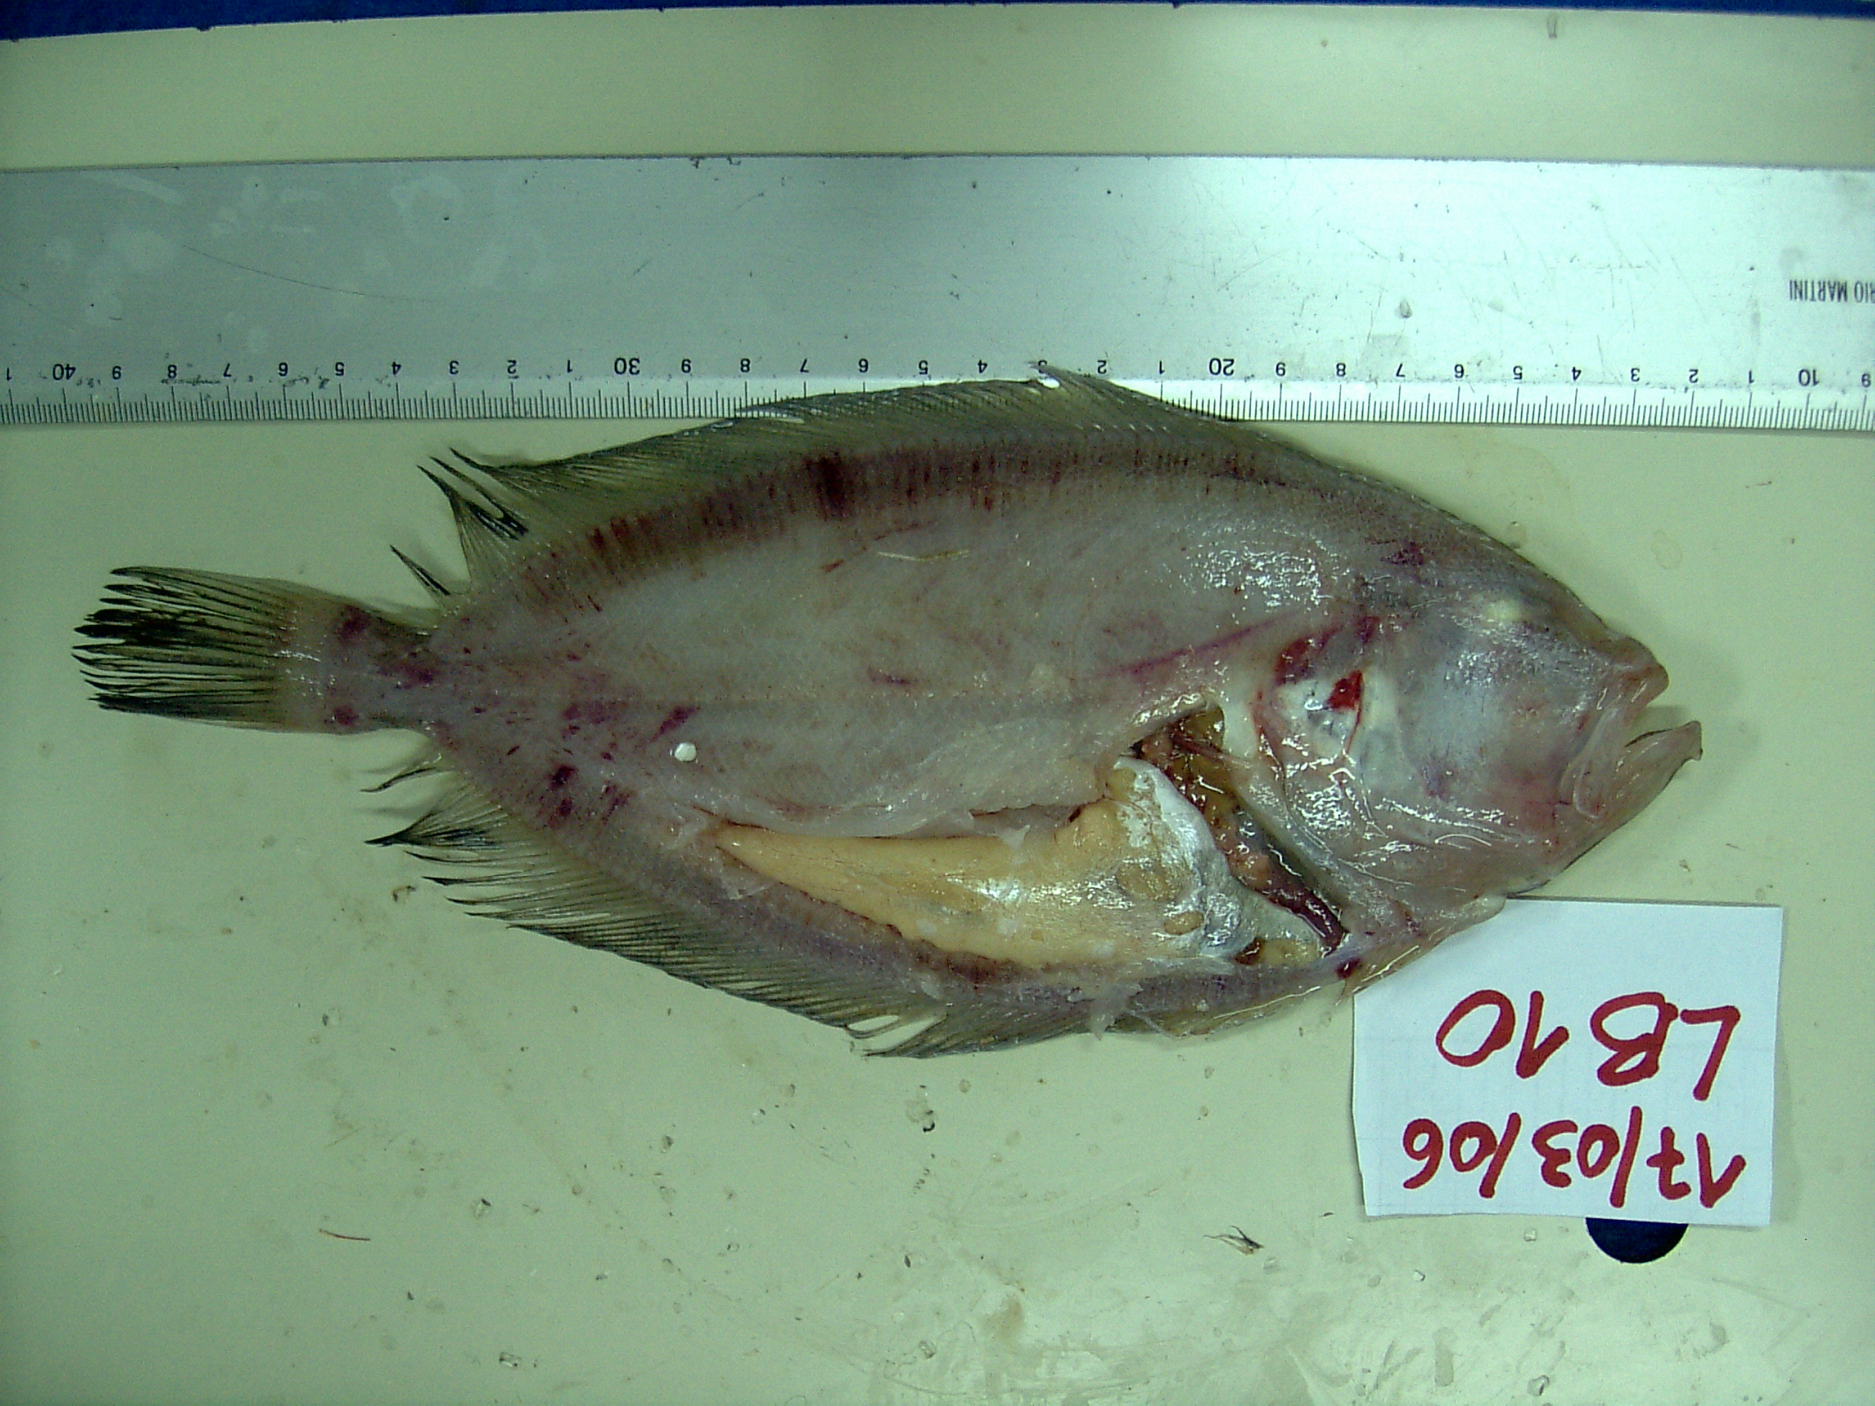
Example 5:

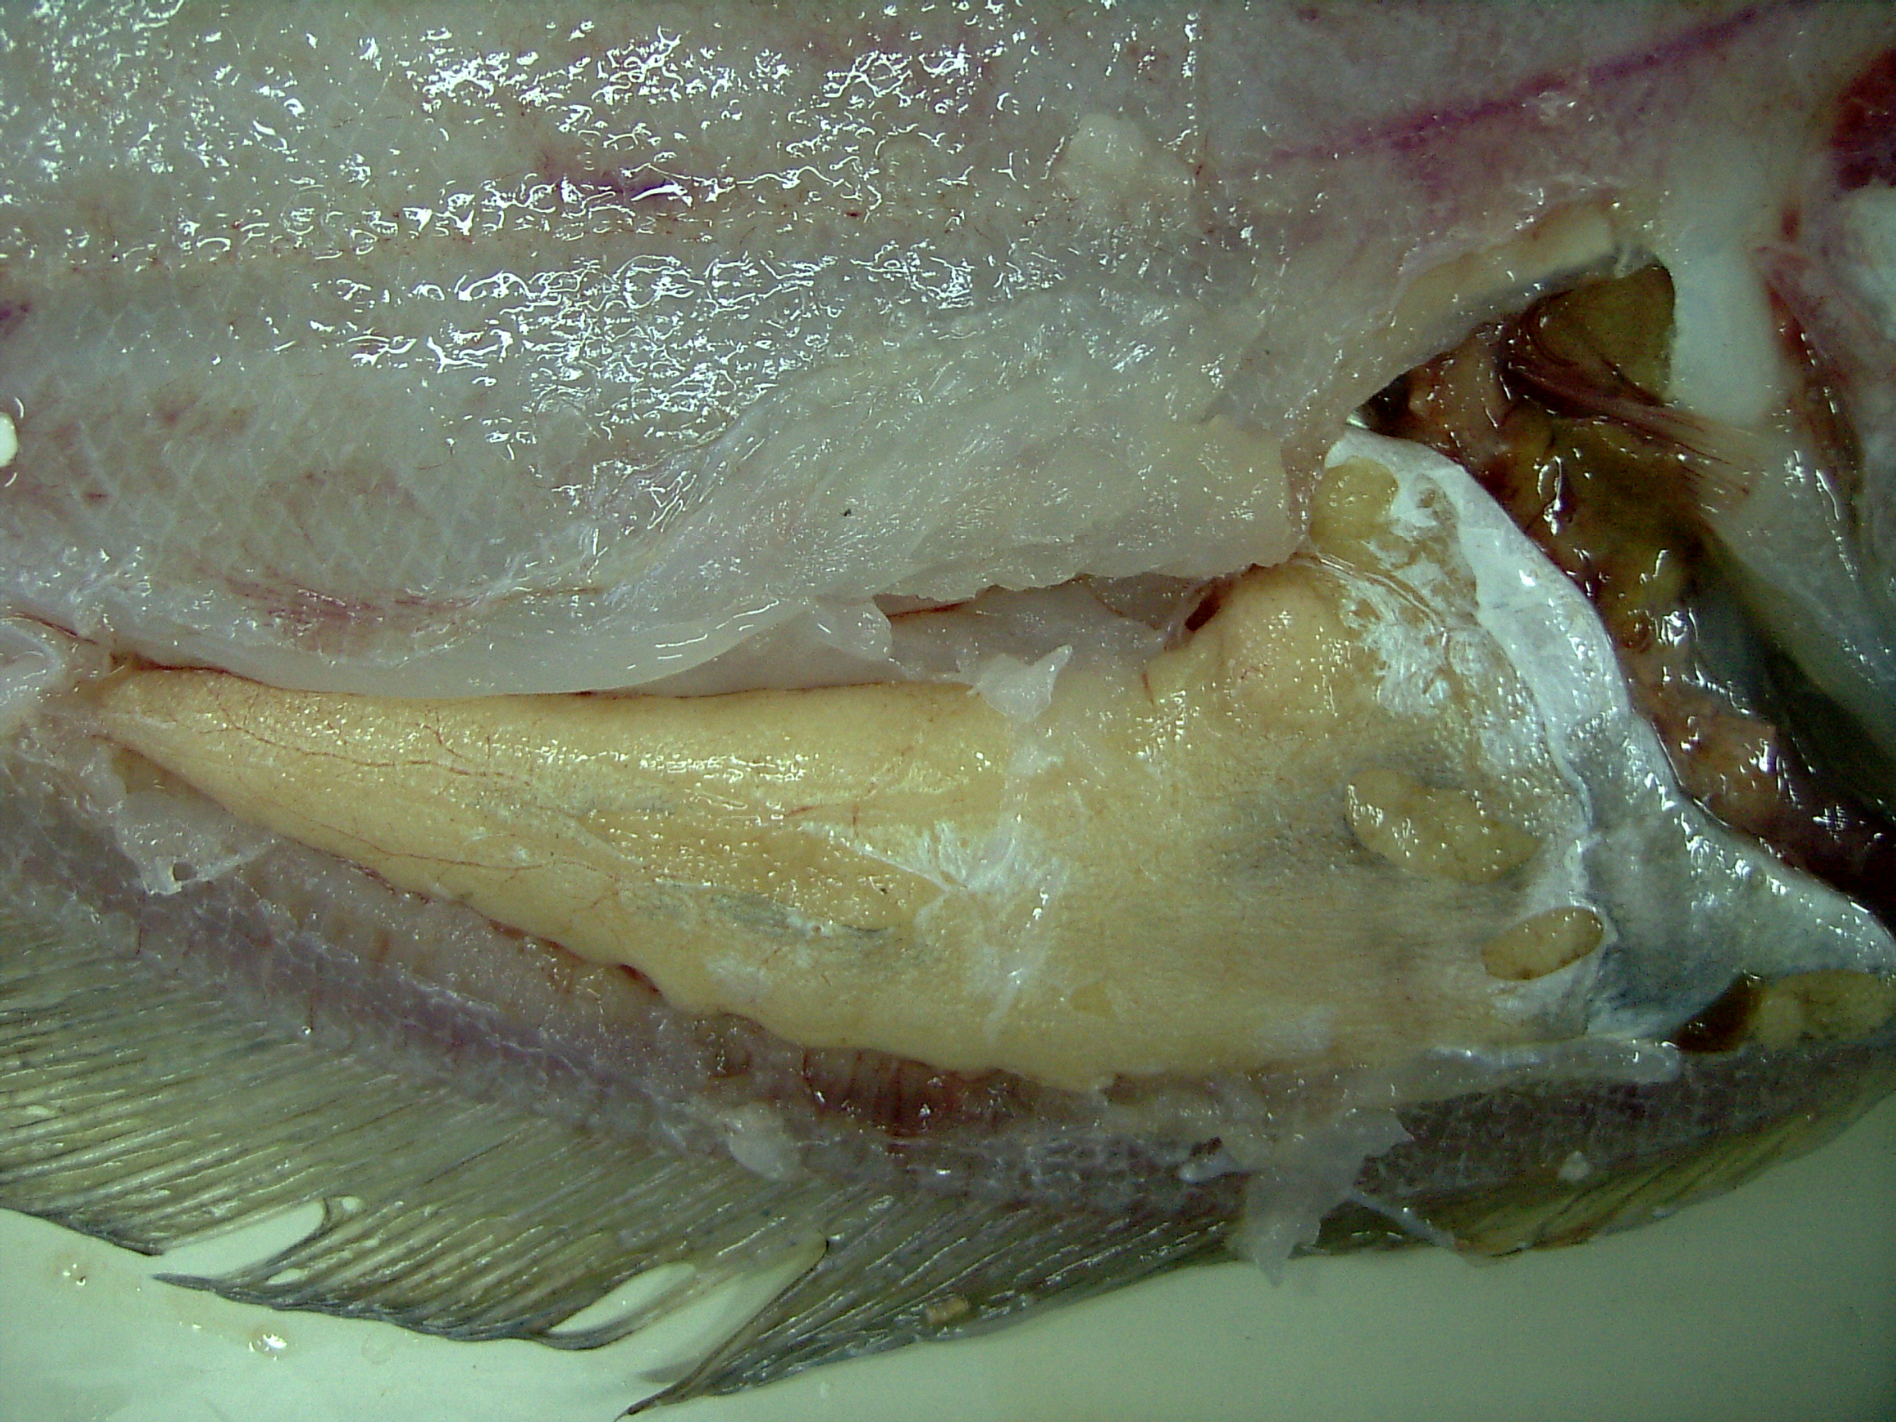

Example 6

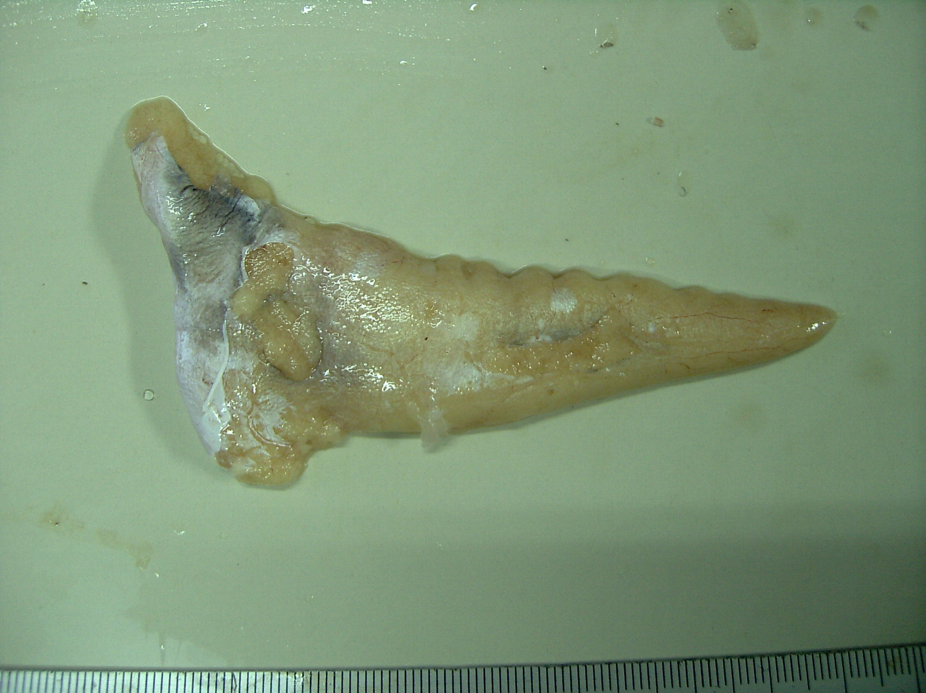
Example 7

