The International Council for the Exploration of the Sea (ICES) offers courses led by high-profile scientists and instructors. Visit the Training web page: www.ices.dk/iceswork/training/training.asp.

How to Lead an Effective Technical Meeting
Context and level
Nearly every scientist attends technical meetings, spending and wasting hours in meeting rooms and on conference calls. Over time they’ll see some meetings run efficiently, making good use of the time to accomplish the meeting’s objectives, and others meetings run poorly, where objectives are never met. Why are some meetings effective and others aren’t? More often than not, it’s due to the meeting leader.
Anyone can become an effective technical meeting leader. As with anything else, it requires learning the skills and gaining experience. During this course, you will do both. The goal of the course is to prepare you to tackle a leadership assignment, and teach you to expect and adapt to challenges you’ll likely face along the way.
The course is different from traditional facilitation courses in the following ways:
- The entire meeting process is covered from meeting design to completion and follow-up;
- Active learning exercises are utilized to immerse course participants in the methods of leadership, allowing participants to learn from each others’ experiences;
- The course is designed for scientists who establish, organize, attend or chair technical meetings of other experts e.g. Working Groups, Workshops, Steering Committees etc and who are required to produce a technical output (report/advice etc).
- Significant time is spent learning how to deal with meeting challenges (e.g., facing difficult personalities, having insufficient time to accomplish meeting goals, lacking proper authority to lead a meeting, failing to establish rules of behaviour).
- Specific ICES items:
  - Working within an international expert group environment.
  - The process of setting up expert groups and reporting their outcomes.
  - Engaging with diverse participants including observers and advice recipients during expert group meetings.

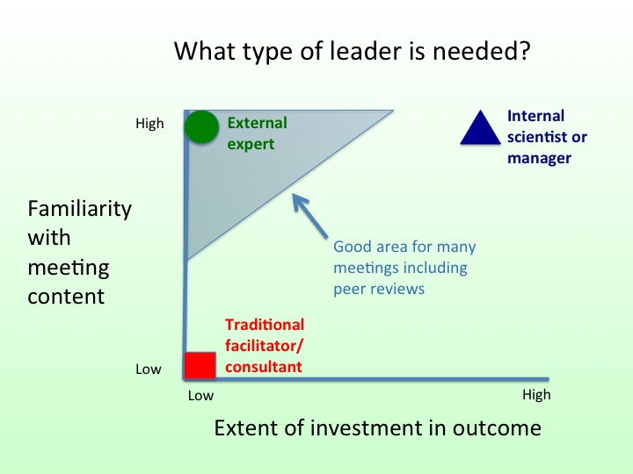

Objective
The general objective of the course is to train scientists and advisors how to be effective technical meeting leaders. Specific objectives include:
- understanding the factors involved in a meeting’s creation that determine its likelihood of success and how those can be modified;
- understanding what background information is and is not needed for a meeting leader;
- understanding how to apply a wide variety of facilitation tools to have a successful meeting, particularly in dealing with problems;
- applying this information to take greater control of your life.
By the end of the course, the participants will:
- be able to assess whether a leadership position is being created in a way that will lead to its successful completion;
- be able to utilize skills to do the preparation needed for a successful technical meeting;
- be able to achieve a meeting’s goals and objectives by utilizing sound facilitation skills;
- be able to build on their success by integrating what they’ve learned into not only their meetings, but into their daily lives.

Course dates
The two-day course will be offered on September 19-20, 2013.

Venue
International Council for the Exploration of the Sea
H. C. Andersens Boulevard 44-46
DK-1553 Copenhagen V
Denmark
Tel: +45 3338 6700
Fax: +45 3393 4215
info@ices.dk
You can find more information about:
ICES HQ here
Hotels close to ICES here
The hostel next to ICES here

Fee
The fee for the course is 225€. This covers only tuition.

Organization
The course is organized by the ICES Secretariat as part of the ICES Training programme. Instructors include:
The course is being taught by Dr. Jim Berkson, a Courtesy Associate Professor at the University of Florida, and Dr. Adi Kellermann, Head of Science for ICES.
The course includes applied examples, case studies, and hands-on exercises.

Admission and registration
The course is designed for a maximum of 30 participants. The working language is English.
Please use the on-line registration:
http://www.ices.dk/iceswork/training/registration/
You will receive a message acknowledging receipt of your application within one week.
The deadline for the submission of applications is
31 July 2013.

Please note that a related course "Communicating Science and Advice" is held immediately before this one and in some cases participation in both courses might be worth considering.

Programme
The 1½ day course is organized as a combination of presentations, discussions, and class exercises.

Section | Topic
1 | What works and what doesn’t?  The good, bad, and ugly
2 | When should you accept leadership?  To lead or not to lead
3 | What preparation is required?  The world is not enough, or is it?
4 | How do you lead a meeting?  Herding cats: Lion taming or kitten coaxing?
5 | How can you apply these skills everyday?  Dirigo, Ergo Vivo (“I direct, therefore I live”)

Instructor
Dr. Jim Berkson has worked as both an academic and an agency scientist, participating in a large number of fisheries forums, for more than 25 years. He has an international reputation for leading successful technical meetings. Combining his experience in both creating active learning courses and in leading national and international technical meetings, Dr. Berkson brings this highly unique and helpful course to ICES.

Dr. Adi Kellermann has worked as both an academic and a governmental scientist for 23 years. He brings solid experience in mediation and facilitation to this course. As Head of Science Program in ICES since 2004, he will incorporate facets of meeting leadership unique to ICES into the course.

Contact ICES Secretariat for more information
Coordinator for Training
Tel: (45) 33 38 67 52
Email: mailto:training@ices.dk

No fee for ICES expert group chairs

