Report of the Blue whiting (Micromesistius poutassou)
otolith exchange 2010 - 2011

18.11.11

by

Sigbjørn Mehl, Elna Sælen Meland and Åge Høines
Institute of Marine Research
Bergen, Norway

sigbjoern.mehl@imr.no
elna.saelen.meland@imr.no
aage.hoines@imr.no

www.imr.no

Table of Contents

1 Introduction 3
2 Participants and circulation path in the blue whiting exchange 3
3 Otolith Collection 4
4 Otolith Exchange set 4
4.1 Reading procedure 4
4.2 Datasheets 4
4.3 Timetable 4
5 Results 5
6 Conclusions/Recommendations 7
7 References 7
Appendix I. Annotating the Otolith Images 8
Appendix II Otolith Reader Colour Selection Table 11
Appendix III. Contact addresses, organizers (in bold) and participants. 12
Appendix IV. Collections of otoliths 13

Introduction

The previous blue whiting otolith ageing workshop took place in 2005 (Clausen et al. 2005). The Planning Group on Commercial Catch, Discards and Biological Sampling (PGCCDBS), has later recommended a new full pre-workshop exchange.

The Institute of Marine Research (IMR), Norway, agreed to organize the otolith exchange and evaluate the results.

The main objective of the exchange was to examine samples of blue whiting otoliths from the most important fishery regions, at different times of the year. Interpreting age of blue whiting is considered relatively difficult.

Otoliths from four regions were included in the exchange.

- ICES Division IVa and IVb, collected in Q1 and Q2 (March 28 – April 05, 2009)
- ICES Division IIa and Va, collected in Q3 (July 20 – August 03, 2009)

Institutes use basically the same method of sample preparation and reading techniques for ageing otoliths of blue whiting. Otoliths are stored dry, but are soaked in water approximately 24 hours prior to age reading.

The objectives of the exchange were to:
- investigate the levels of agreement on age readings
- analyse the relative differences between reader ages
- compare readings by area

Participants and circulation path in the blue whiting exchange

- The Faroe Islands January 2010
- Ireland February 2010
- Russia March/April 2010
- Portugal May 2010
- Great Britain June 2010
- Greece¹ July/August 2010
- Netherlands August/September 2010
- Germany October 2010
- Iceland November 2010
- Spain December 2010
- Denmark January 2011, delayed to February 2011
- Norway February 2011, delayed to June 2011
¹Greece were not able to complete the project due to a resignation during the project period

Contact addresses, name and e-mail of the organizers and participants are given in Appendix III.

Otolith Collection

In this exchange, there were two collections of otoliths (the right otolith) and a CD:

- Q1 and Q2 VIa and VIb otoliths, collected from fish harvested in the period March 28 to April 05, 2009. Total 105 otoliths, numbered 1-105. Further details of position and date of catch, and fish size are given in Appendix IV.
- Q3 IIa and Va otoliths, collected from fish harvested in the period July 20 to August 03, 2009. Total 84 otoliths, numbered 106-189. Further details of position and date of catch, and fish size are given in Appendix IV.
- CD containing the digitized images of the two otolith sets. Protocol for annotating the otolith images is presented in Appendix I, and Appendix II shows the otolith reader colour selection table.

Otolith Exchange set

Reading procedure

The otoliths were read in accordance with the convention. Birthday is assumed to be 1st January. The readers had available information about fish length, weight, date of catch and position. Each reader was supposed to interpret the otoliths as an individual and not to see or be influenced by the results produced by other readers. Only one age estimate per otolith was provided and an age was assigned for all otoliths. In total everybody should read 189 otoliths. The readings were documented by annotating the translucent annuli on the digitized pictures using Paintshop Pro or Photoshop software. The colour used was put in the “Otolith Reader Colour Selection Table” (Appendix II).

The results (xls-sheet) were emailed to Elna Sælen Meland (elna.saelen.meland@imr.no), and a CD or DVD with the annotated layers and were sent to:

Elna Sælen Meland
Institute of Marine Research
P.O. Box 1870 Nordnes
5817 Bergen, Norway

Datasheets

Data sheets in Excel format were distributed by email. The datasheets were completed with age readings and a clear indication of the reader and country. Data of fish length, sex, date at capture and ICES area were included.

Timetable

Otolith samples are fragile and were well protected when packed and sent from the organizer. However, already when the first institute (The Faroe Islands) received the otoliths, quite a few had broken tips. Therefore also the left otholiths were included in the package and sent around, but still more otoliths were damaged, and some of the latest readers only used the images to determine the age (readers 1, 2, 6, 11 and 14). The organizer was notified by email when the parcel left and arrived at each institute so its progress could be monitored. When ageing was completed, the samples were sent to the next institute on the reading schedule list and an e-mail with completed age data sheets was sent to elna.saelen.meland@imr.no. The addresses for each institute and the person to whom the package should be sent are in Appendix III.

Results

Results for all readers and assessment data readers are presented in Appendices V and VI, respectively (Tables A5.1-5/A6.1-5) and Figures A5.1-5/A6.1-5).

The AGE COMPARISON.XLS excel workbook (by Guus Eltink, RIVO, Ijmuiden, The Netherlands) is considered to be the standard method of analyzing precision, accuracy etc. and thus is the tool used most widely for the analysis of age determination results by individual readers, see Appendices V and VII. The spreadsheets were completed according to the instructions contained in Guidelines and Tools for Age Reading Comparisons (Eltink et al. 2000).

Table A5.1 (Appendix V Table 1) contain the sample information and the input data of the age readings by reader. Readers were first tentatively assigned numbers in accordance with their anticipated experience levels. The Guus Eltink spreadsheet is set up in such a way that the most experienced reader must be positioned in the left most column thus as you go from left to right the readers are less experienced. If there is no clear mode, modal age is determined by the age estimate of the reader in the leftmost column of the workbook, i.e. the most experienced reader. Therefore it is important to consider which reader should occupy the leftmost column. In the case of a possible tie on two modal ages from a group of readers, the most experienced reader’s determination of the age will take precedence. Due to some uncertainty about the different reader’s experience, the numbering was later re-arranged according to the ranking.

21 readers participated in the exchange, of which nine readers participated during the 2005 workshop (readers 2, 3, 4, 5, 9, 11, 14, 18 and 20, see Appendix III for names). The modal age was calculated from readers 1 to 10 as these readers had the best overall ranking. Four of these were Norwegian. Readers 7 and 8 showed a relatively large negative bias for the oldest ages, but not including them in the basis for the modal age would increase the Norwegian dominance. 11 readers (reader 1, 2, 3, 4, 7, 8, 9, 10, 14, 20, 21, see Appendix III for full name) contribute age data to the stock assessment of blue whiting, and separate EFAN analyses were performed for these readers (Appendix VI). In this analysis the modal age was calculated from readers 1, 2, 3, 4, 7, 8, 9 and 10.

In Tables A5.1/A6.1 modal ages were calculated for each otolith read, along with percentage agreement, mean age and precision CV, where percentage agreement = 100 x (no. of readers agreeing with modal age / total no. of readers) (for each otolith) and precision CV = 100 x (standard deviation of age readings/ mean of age readings) (for each otolith). Percentage agreement ranged from 15 to 95% with an average of 46.4%. Of the 189 otoliths, only 17 (9%) were read with at least 80% agreement. The precision CV ranged from 6% to 57%, with an average of 17.1%. For analyses with the 11 readers contributing to the assessment, the average percentage agreement increases to 52%, while the CV is reduced to 15.6%. In the 2005 workshop the overall agreement was 86.5 % with a precision of 12.2% CV and for 57% of the otoliths the agreement was larger than 90%.

Tables A5.2/A6.2 examine the readings of individuals at each modal age and summarises the number of otoliths read, the precision CV, percentage agreement and relative bias of each reader. One of the Norwegian readers decided to age determine only 163 out of 189 fish due to some difficult otoliths, especially from older fish. Of the 3969 age readings requested in this exchange, 3940 were supplied. Only one reader had CV below 10%, seven readers had CV between 10 and 15%, seven readers had CV between 15 and 20%, while six readers had CV above 20%. Percentage agreement showed similar variation. Only reader 1 achieved over 80% agreement over all the ages, reader 2 had 71% agreement and reader 3 had 66%. Readers 4, 5, 6, 7, 9 and 10 had between 50 and 60% agreement, while the remaining twelve readers had below 50% agreement. For all readers the average percentage agreement relative to the modal age ranged from 30 to 70%, highest for the youngest and lowest for the oldest. The CVs ranged from 15.8 to 25.6%, and highest for the youngest, but this may partly be due to a lower number of observations in these age groups. For analyses with the 11 readers contributing to the assessment, the percentage agreement relative to the modal age ranged from 39 to 70%, while the CVs ranged from 13.3 to 24.6%.

The relative bias tables demonstrate the difference between the mean age for each age group and the modal for each age group. Readers 1, 2, 3, 4, 6, 10 and 15 show positive relative bias and overestimates the age relative to modal age, while the other readers underestimate. For individual readers the relative bias varied from + 0.56 to -1.49 and for all readers combined the bias was found to be -0.35. For analyses with the 11 readers contributing to the assessment, the relative bias varied from +0.29 to -1.53, and for all readers combined the bias was found to be -0.34. The negative bias increased with fish age.

Figures A5.1/A6.1 are graphical representations of the relative bias table in Tables A5.2/A6.2. The data for each reader which is plotted in Figures A5.1/A6.1 is derived from Tables A5.6/A6.6. In these age bias plots any deviation of the points from the solid line indicates a bias when the reader’s age estimates are compared with the modal age. Points above and below the line indicate a positive and negative bias, respectively. The vertical bars are drawn plus and minus two standard deviations from the mean age. Short bars indicate consistency of reading at a given modal age. Figures A5.2/A6.2 is a graphical representation of the coefficient of variation and percentage agreement panels in Tables A5.2/A6.2.

In the overall ranking table, readers 1, 2, and 3 are ranked in the top three positions for CV, percentage agreement and relative bias in both analyses.

Figures A5.3/A6.3 show the distribution of the age reading errors in percentage by modal age as observed from the whole group of age readers in an age reading comparison to modal age. Some relative negative bias is evident, especially for older fish (Figures A5.4/A6.4).

Tables A5.3/A6.3 show the age compositions and the mean length at age obtained by each reader and all readers combined and also the Inter-reader bias test and reader against modal age bias test. Those readers who overestimated the fish ages in the collection in effect assigned older ages to smaller fish. Thus the mean length of the fish aged at each age group by these readers tends for the most part to be smaller than the mean lengths of the fish at the same age groups aged by the other readers (see Mean length at age table in Tables A5.3/A6.3 and Figures A5.5/A6.5).

The inter reader bias tests are presented in the bottom panel of Tables A5.3/A6.3. Of 210 possible combinations, 160 (76%) were found significantly different (certainty of bias, p<0.01), 14 (7%) had a possibility of bias (0.01<p<0.05), while 36 (17%) had no sign of bias (p>0.05). In the analyses for the 11 readers contributing to the assessment, 40 of 54 combinations (74%) were found significantly different (certainty of bias, p<0.01), 3 (6%) had a possibility of bias (0.01<p<0.05), while 11 (20%) had no sign of bias (p>0.05). When comparing each reader to modal age, the percent showing certainty of bias, possible bias and no bias were 76, 10 and 14, respectively. For analyses with the 11 readers contributing to the assessment, the corresponding figures were 82, 0 and 18%, respectively.

The age readings are summarised by month of sampling in Tables A5.4/A6.4. Samples were obtained in four months. Highest percentage agreement was found for otoliths collected in March and April and lowest for July and August. Tables A5.5/A6.5 summarise the results by the sample origin in terms of ICES division. Highest percentage agreement was found for otoliths collected in ICES area VIb and lowest in area IIa.

Conclusions/Recommendations

An agreement level with the modal age between age readers of 90% is considered desirable for some species, especially for readers supplying ages to an assessment working group. The overall percentage agreement for this exchange was only 46.4% and the overall precision CV was 17.1%, which is not satisfactory, even if blue whiting is considered somewhat difficult to age determine. For analyses with the 11 readers contributing to the assessment, the corresponding results were 52% agreement and a CV of 15.6%, which is only a marginal improvement. Underestimation of older ages seems to be one of the problems when interpreting ages of blue whiting. There is also a too high level of bias between readers from many institutes.

The results are considerably poorer than what was obtained during the previous ageing workshop (Clausen et al. 2005) in spite of the ageing protocol/guidelines defined then. This may partly be due to a higher number of inexperienced participants and a more complex otolith material with a higher proportion of older fish. Only nine of the twenty-one readers participated in the 2005 workshop, and six of these nine delivers age reading data to the assessment. An important factor is also that already when the first institute (The Faroe Islands) received the otoliths, quite a few had broken tips. Therefore also the left otoliths were included in the package and sent around, but still more otoliths were damaged, and some of the latest readers only used the images to determine the age.

However, the result suggests that a new workshop is needed to standardize the age reading between laboratories and to ensure the implementation of the ageing protocol/guidelines.

The protocol for annotating otolith images was not follow by all institutes and readers, some used Photoshop instead of Paintshop Pro and some delivered JPEG-files. It is therefore recommended that all users annotate the images again before a workshop applying WebGR.

References

Clausen, L.W., Power, G., Timoshenko, N. and Tangen, Ø. 2005. ICES Planning Group on Commercial Catch, Discards and Biological Sampling (PGCCDBS). Report of the Blue Whiting Otolith Ageing Workshop. DIFRES, Hoitshals, Denmark, 13-16 June 2005.

Eltink A.T.G.W., Newton, A.W, Morgado, C., Santamaria, M.T.G. and Modin, J. 2000. Guidelines and Tools for Age Reading Comparisons. Version 1 October 2000. EFAN Report 3-2000.

Appendix I. Annotating the Otolith Images

The otolith package contains a CD with an image of each otolith in the exchange, arranged in folders according to processing method.

All readers are asked to create a ‘named’ raster layer for each digital image and to annotate every annual translucent ring on each otolith, on a raster layer.
N.B. Each reader must interpret the otoliths as an individual and must not see or be influenced by the results produced by other readers. These annotated images enable comparisons of how readers derive their age readings and form a valuable record of the exchange that can also be used as a training resource for less experienced readers.

For each age reader:

1. Copy the entire folder to a personal computer for each reader.

2. Create a new folder and rename it with the age reader’s name,

The following illustrations are for Paintshop Pro X, but the basic instructions apply to other compatible versions of Paintshop Pro (V7.02 to X).

3. Use the ‘File’ menu in Paintshop Pro to locate and open the first otolith image.

4. Use the Layers menu to create a new Raster Layer.
4.1 Select new Raster Layer
4.2 Rename the layer with the Age Reader’s name
4.3 Click OK
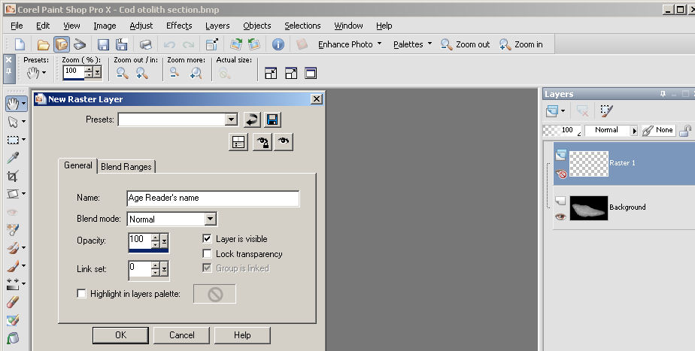
4.1
4.2
4.3

5. Select brush tool shape, size and hardness as specified for the exchange
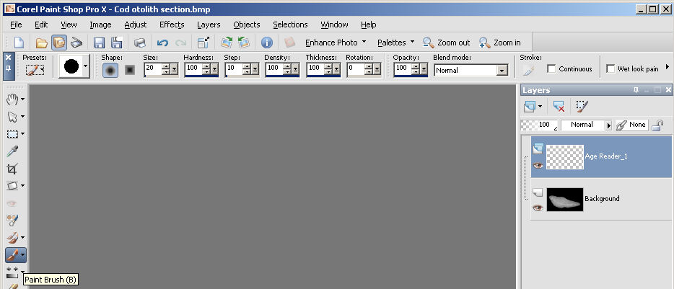
5.1
5.2
5.4
5.3

6. Open the Colour Palette
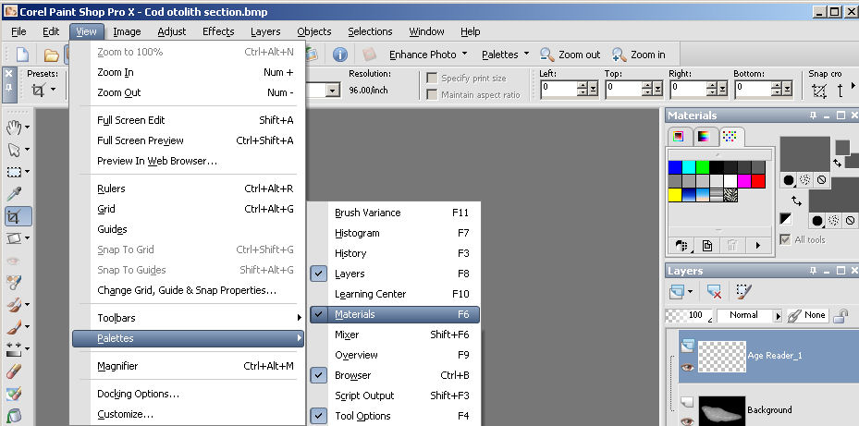
6.1
6.2
6.3

7. Select a colour from those remaining after each reader has examined the otoliths (see otolith reader colour selection table). Readers please complete the table with your selected colours before passing the otoliths to the next recipient.

7.1 Create a new Colour Swatch
7.2 Rename the Colour Swatch with the Age Reader’s name
7.3 Set the unique Red, Green, Blue, colour for the age reader
– in this case R=192, G=255,B=192 (Lime Green).
7.4 Save the Colour Swatch

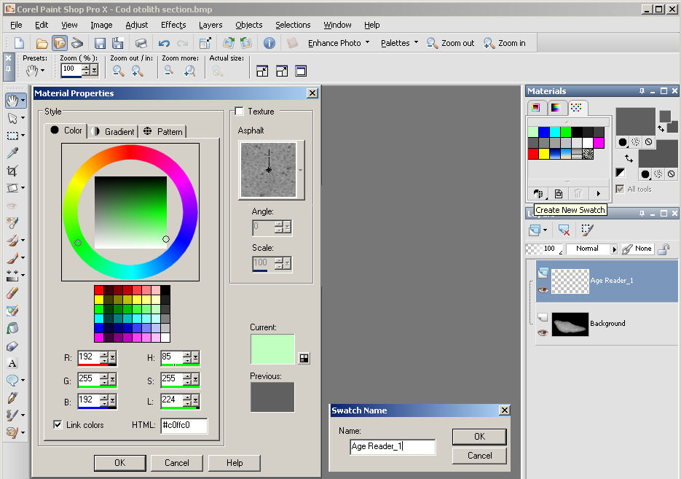
7.1
7.2
7.3
7.4

8. Mark the position of each annual translucent zone (annulus) with a single round dot.

9. Use ‘File’ + ‘Save As’ to add the age reader’s name to the image name e.g. ‘Image Name_Age Reader Name’, and save the image as Paintshop Pro ‘.pspimage’ file.
10. Repeat steps: 3, 4, 8 and 9 for each otolith to be aged.
11. Repeat the entire process for each age reader.

Appendix II. Otolith Reader Colour Selection Table

Institute | Otolith Reader | Colour | RGB
Institute | Otolith Reader | Colour | Red | Green | Blue
FAMRI, Faroe Islands | Lis Larsen | Bright Red | 255 | 0 | 0
MI, Ireland | Eugene Mullins | Lime Green | 0 | 255 | 0
 | Susan Beattie | Turquoise | 0 | 255 | 255
Russia, PINRO | Ekaterina Murashko | Navy | 0 | 0 | 128
 | Ivan Oganin |  | 6 | 162 | 11
 | Rimma Maslova |  | 1 | 179 | 233
 | Tatyana Prokhorova |  | 72 | 236 | 6
Russia, AtlantNIRO | Nikolay Timoshenko |  | 255 | 64 | 255
Portugal | Ana Luisa Ferreira | Bright Yellow | 255 | 255 | 0
CEFAS, UK | Dave Brown | Cerise | 255 | 0 | 255
 | Mark Etherton | Black
vTI, Germany | Torve Christiansen | Orange | 255 | 126 | 1
MRI, Iceland | Sigrun Johannsdottir | Burgundy | 128 | 0 | 0
IMARES, Netherlands | Thomas Pasterkamp | Baby pink | 255 | 192 | 255
Spain | Rosendo Otero | ?
DTU AQUA Den | Helle Rasmussen | Royal blue | 0 | 0 | 255
Norway | Elna Sælen Meland | ?
 | Jan de Lange | Lilac
 | Øyvind Tangen | Dark green
 | Jaime Alvarez | Dark grey
 | Kirsti Børve Eriksen | Pale blue

Appendix III. Contact addresses, organizers (in bold) and participants.

Country | Participants | E-mail
Faroe Marine Research Institute, Nóatún, FO-100,  Faroe Islands | Jan Arge Jacobsen  Lis Larsen * | janarge@hav.fo  LisL@hav.fo
Marine Institute, Rinville,  Oranmore, Co. Galway,  Ireland | Eugene Mullins ¤ *  Susan Beattie ¤ * | eugene.mullins@marine.ie  susan.beattie@marine.ie
Polar Research Institute of Marine Fisheries and Oceanography (PINRO),  6, Knipovich st., Murmansk,  183763 Russia | Tatyana Prokhorova ¤ *  Ekaterina Murashko  Rimma Maslova  Ivan Oganin  Nikolay Timoshenko ¤ | alice@pinro.ru  kattim@pinro.ru  maslova@pinro.ru  oganin@pinro.ru  timoshenko@atlant.baltnet.ru
IPIMAR, Av. Brasilia,  1449-006, Lisboa, Portugal | Ana Luisa Ferreira * | aferreira@ipimar.pt
CEFAS, Lowestoft Laboratory, Pakefield Road,  Lowestoft, Suffolk, NR33 0HT, United Kingdom | Mark Etherton  Dave Brown | Mark.etherton@cefas.co.uk  dave.brown@cefas.co.uk
IMARES, Postbus/P.O Box 68, 1970 AB IJmuiden  The Netherlands | Loes Bolle  Thomas Pasterkamp * | loes.bolle@wur.nl  thomas.pasterkamp@wur.nl
Von Thunen Institute,  Institute for Sea Fisheries,  Palmaille 9, 22767 Hamburg,  Germany | Jens Ulleweit  Torve Christiansen | Jens.Ulleweit@vti.bund.de  torve.christiansen@vti.bund.de
Marine Research Institute, P.O. Box 1390, Skulagata 4, 121 Reykjavik,  Iceland | Sveinn Sveinbjörnsson  Sigrun Johannsdottir * | sveinn@hafro.is  sigrun@hafro.is
Instituto Español de Oceanografia, Centro Oceanografico de Vigo,  36200 Vigo, Spain | Manuel Meixide  Rosendo Otero ¤ * | maolo.meixide@vi.ieo.es  rosendo.otero@vi.ieo.es
National Institute of Aquatic Resources, Section of Population and Ecosystem Dynamics,  Charlottenlund Castle DK-2920, Denmark | Lotte Worsøe Clausen  Helle Rasmussen ¤ * | law@aqua.dtu.dk  hr@aqua.dtu.dk
Institute of Marine Research,  P.O. Box 1870 Nordnes,  5817 Bergen, Norway | Elna Sælen Meland *  Jan de Lange ¤ *  Øyvind Tangen ¤  Jaime Alvarez  Kirsti Børve Eriksen ¤ | elna.saelen.meland@imr.no  jan.de.lange@imr.no  øyvind.tangen@imr.no  jaime.alvarez@imr.no  kirsti.boevre.eriksen@imr.no

¤ Participated in the 2005 workshop
* Readers delivering data to the blue whiting assessment

Appendix IV. Collections of otoliths

